1:In order to add Menu at runtime, creat new xml file on App_Data folder and customise ur menus

then add xmldatasourse control and configure it to see ur xml file.

then bind ur menu control to this data source

then on the menu, select: Edit menuitem databinding and add both the contrloType and Control.

then in the textfield select Name for both contrloType and Control. next select url for the control

2: Tree veiw works like menu cotrols. if u want the category to be colapsing, set Expanded.

To also add nodes to tree at runtime, do what we did for menu above.

3: to add sitemap to app, click on solution file then add new item. as you try to type site on the search textbox on a proxy

template the sitmap pop out itself. click on site map for c# and leave the name as web.sitmap,click ok.

sitemap should not have a duplicate url. Unlike xml file where deleloper define their own variable, in sitemap, we have key words.

After structuring the sitemap, open a web form called say "testsitemap".on the form add a tree view control and a sitemapedatasource control.

Dont confifure bcos by default its already bind to the web.sitmap file created. Just bind the tree menu to the sitemapdatasourse control added.

If u want the sitemapPath to be clickable, set the sitemap session url to a link

4: Ajax Controls help to suppress or hide Postback functionality of a control. its makes this postback to happen at the background while

u continue with the page then present the result on the page when ready. Simply put the form inside a control called:UpdatePanel. to make

the user relax and sure thst the action is on at the background put a control:updateprogress

5: if we to timer_tick event handle to display inside a wed browser, we type on title tag on the file with Ajax functionailty

<title id="myTitle" runat="sever". then target this in the timer control on the c# code.i.e myTitle.text=label5.text

6:viewstate as one of the data persistent control has a page level scope. the value rmain throughout for all the functions on that page.

the value is lost when u leave the page.

NOTE: while the viewstate has the scope of page level the session object has the scope of site level. session data is basically unique to each

user. value is the same on the same browser diff tab but different in anothe browser as this is seen as anothetr user.

Session: in oeder to keep the unique names of all the session variable, create a class to store all these variables. open a defau;lt folder

called APP_code inside ASP.Net Folder.U can store all classes here.

create a private string variable, right click on the variable and select refraction and attonation and pick the first option.

A public method will be generated. remove ur private variable name and put:=> HttpContext.Current.Session["sess_userName"].ToString();

set => HttpContext.Current.Session["sess_userName"] = value;

7: the period of time a user logs into a site and stays on it is called a session

8: Cookies: while session variables are stored in the server memory, cookies are stored in the client or visitors' hard disk. we have both

temporary and persistent cpookies. when a temp. cookie is created, it can be used any where in the site so long as the browser is not closed.

9 Another data persistent technique is the used of application objects.

NOTE: Diff while session variables are uniqu to each user of the site, application objects are common to all users of the site.

variable that u know all users we need. they stored in in a special file known as Global.aspx. so add this file as u did with App_Code.

Object Value Application variable are never lost as long server is not restarted.

10 another data persistent technique: url querystring. u need it passing data btw page. But dont pass both large and confidentil info

as it is visible in the address bar.check DPExamle.aspx

11: creating a stored procedure: CREATE PROCEDURE uspUserDetailInsert

(

@userName varchar(50),

@passWord varchar(50),

@country varchar(50),

@email varchar(50)

)

AS

BEGIN

INSERT INTO userDetails(userName,password,country,email) VALUES(@userName,@passWord,@country,@email)

END

12: test a procedure on ssms: EXECUTE [procedure name] 'values1','value2' then execute

13: Note: For a class in app_Code to be visible, right click on the class and set build action to compile

14: to create membership control, open developer prompt and type:aspnet_regsql and press enter. then follow the window instruction

15: u need to configure web.cong file by going to the following location to machine.cong

Then search for membership provider, copy the section and past in the web.cong.

\

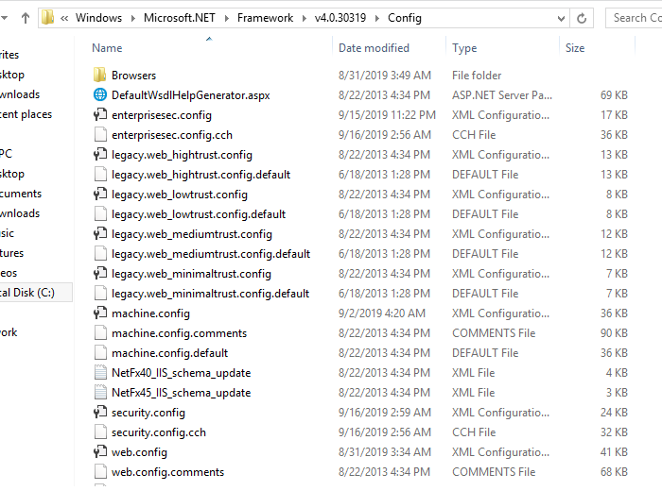

16: to make use of membership provider, set the Autentication mode to ‘ form’

<authentication mode ="Forms"></authentication>

17 ASP.NET NEW FEATURES: Viewstatemode disabled at page level but enable at control level

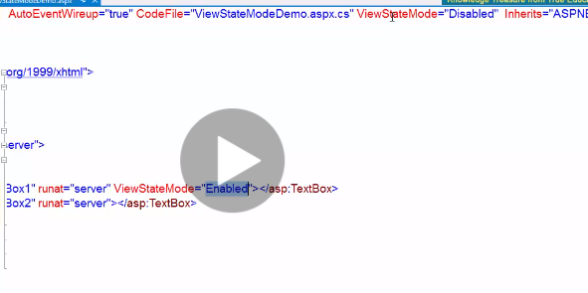

18

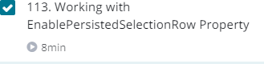

New feature for gridview and listview. It helps to keep a unique selection of record in a page when u enable pagging. Just set it to true and also specify the row primary id .

Select the page index change event . doubleclick it and put this code:

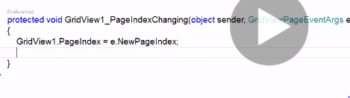

19 You can also set the metal keyword of ur site on source view page and on code behind window to enhance SEO

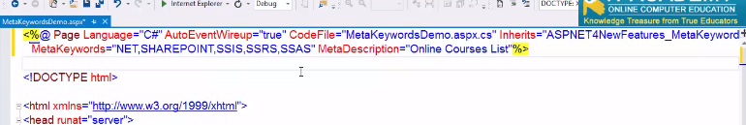

AND C# code

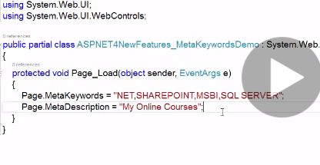

20: Response.RedirectPermanent is used for SEO of new homepade developed or update made on old home page

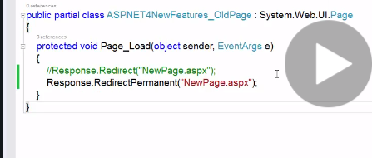

You can “Fiddler web debogger” to analyse what happens behind the scene